Lab – Address Resolution Protocol (ARP)
Topology
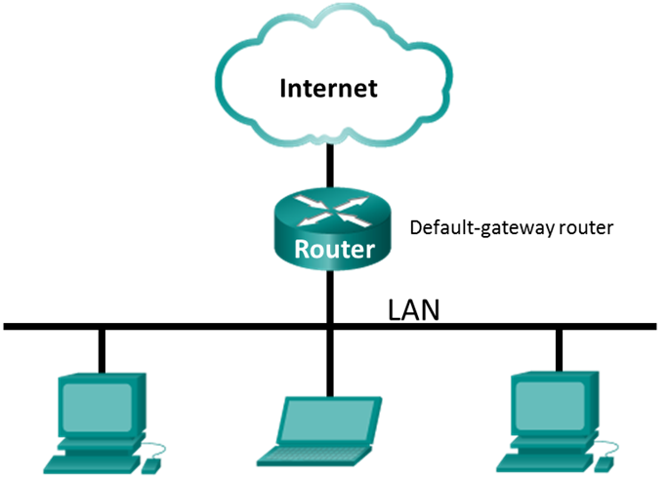

Objectives
Part 1: Download and Install Wireshark
Part 2: Capture and Analyze ARP Data in Wireshark
- Start and stop data capture of ping traffic to remote hosts.
- Locate the IPv4 and MAC address information in captured PDUs.
- Analyze the content of the ARP messages exchanged between devices on the LAN.
Part 3: View the ARP cache entries on the PC
- Access the Windows Command Prompt.
- Use the Windows arp command to view the local ARP table cache on the PC.

Background / Scenario
Address Resolution Protocol (ARP) is used by TCP/IP to map a Layer 3 IPv4 address to a Layer 2 MAC address. When an Ethernet frame is transmitted on the network, it must have a destination MAC address. To dynamically discover the MAC address of a known destination, the source device broadcasts an ARP request on the local network. The device that is configured with the destination IPv4 address responds to the request with an ARP reply and the MAC address is recorded in the ARP cache.
Every device on the LAN maintains its own ARP cache. The ARP cache is a small area in RAM that holds the ARP responses. Viewing an ARP cache on a PC displays the IPv4 address and the MAC address of each device on the LAN with which the PC has exchanged ARP messages.
Wireshark is a software protocol analyzer, or "packet sniffer" application, used for network troubleshooting, analysis, software and protocol development, and education. As data streams travel back and forth over the network, the sniffer "captures" each protocol data unit (PDU) and can decode and analyze its content according to the appropriate protocol specifications.
Wireshark is a useful tool for anyone working with networks and can be used with most labs in the Cisco courses for data analysis and troubleshooting. This lab provides instructions for downloading and installing Wireshark, although it may already be installed. In this lab, you will use Wireshark to capture ARP exchanges on the local network.
Required Resources
- 1 Windows 10 PC with Internet access
- Additional PC(s) on a local-area network (LAN) will be used to reply to ping requests. If no additional PCs are on the LAN, the default gateway address will be used to reply to the ping requests.
- Download and Install Wireshark
Wireshark has become the industry standard packet-sniffer program used by network engineers. This open source software is available for many different operating systems, including Windows, Mac, and Linux.
If Wireshark is already installed on your PC, you can skip Part 1 and go directly to Part 2. If Wireshark is not installed on your PC, check with your instructor about your academy’s software download policy.

Step 1: Download Wireshark.
      - Wireshark can be downloaded from www.wireshark.org.
      - Click Download.

      - Choose the software version you need based on your PC’s architecture and operating system. For instance, if you have a 64-bit PC running Windows, choose Windows Installer (64-bit).
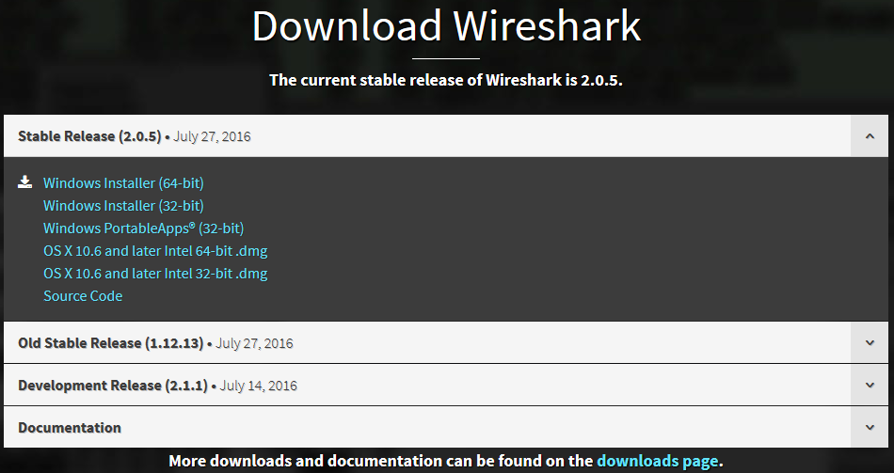
      - After making a selection, the download should start. Click Save File if prompted. The location of the downloaded file depends on the browser and operating system that you use. For Windows users, the default location is the Downloads folder.
    - Install Wireshark.
      - The downloaded file is named Wireshark-win64-x.x.x.exe, where x represents the version number. Double-click the file to start the installation process. It is version 2.0.5 in this example.
      - Respond to any security messages that may display on your screen. If you already have a copy of Wireshark on your PC, you will be prompted to uninstall the old version before installing the new version. It is recommended that you remove the old version of Wireshark prior to installing another version. Click Yes to uninstall the previous version of Wireshark.
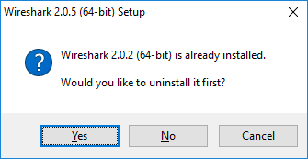
      - If this is the first time to install Wireshark, or after you have completed the uninstall process, you will navigate to the Wireshark Setup wizard. Click Next.
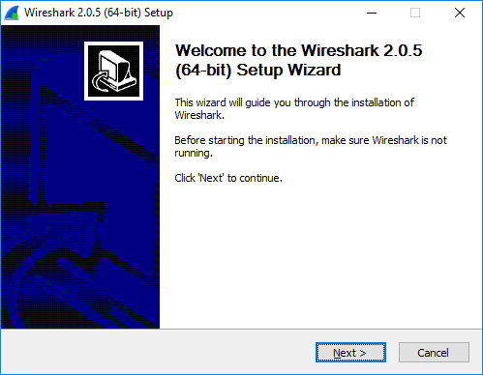
      - Continue advancing through the installation process. Click I Agree when the License Agreement window displays.
      - Keep the default settings on the Choose Components window and click Next.
      - Choose your desired shortcut options and click Next.
.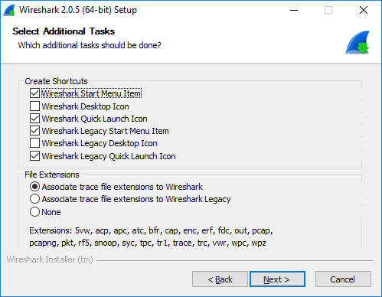
      - You can change the installation location of Wireshark, but unless you have limited disk space, it is recommended that you keep the default location.
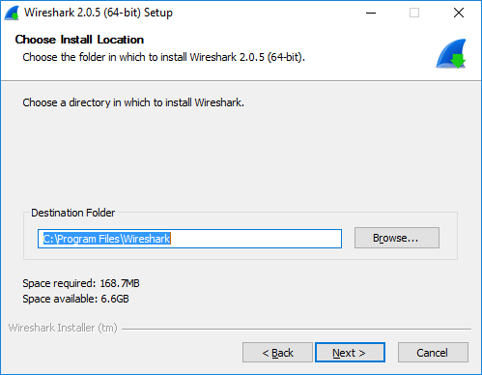
      - To capture live network data, WinPcap must be installed on your PC. If WinPcap is already installed on your PC, the Install check box will be unchecked. If your installed version of WinPcap is older than the version that comes with Wireshark, it is recommend that you allow the newer version to be installed by clicking the Install WinPcap x.x.x (version number) check box.
Finish the WinPcap Setup Wizard if installing WinPcap.
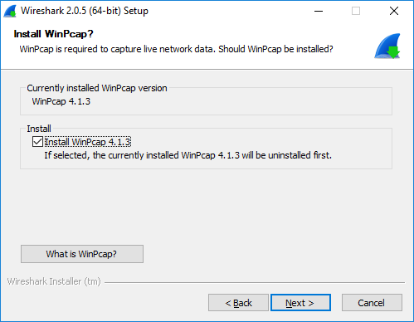
Note: You maybe prompted to install USBPcap. The installation of USBPcap is optional.
      - Wireshark starts installing its files and a separate window displays with the status of the installation. Click Next when the installation is complete.
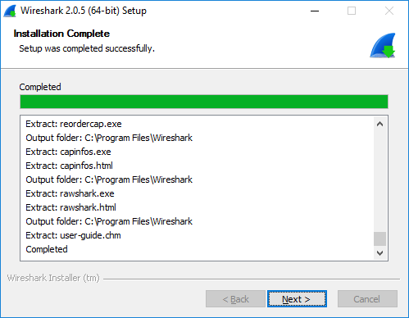
      - Click Finish to complete the Wireshark install process.
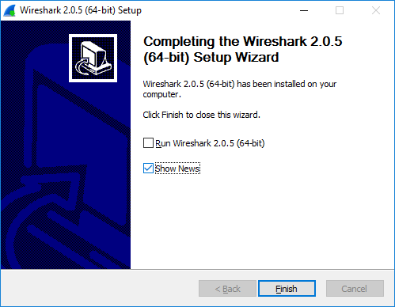
- Capture and Analyze Local ARP Data in Wireshark
In Part 2 of this lab, you will ping another PC on the LAN and capture ARP requests and replies in Wireshark. You will also look inside the frames captured for specific information. This analysis should help to clarify how packet headers are used to transport data to their destination.
    - Retrieve your PC’s interface addresses.
For this lab, you will need to retrieve your PC’s IPv4 address and the MAC address.
      - Open a command window, type ipconfig /all, and then press Enter.
      - Note which network adapter that the PC is using to access the network. Record your PC interface’s IPv4 address and MAC address (Physical Address).
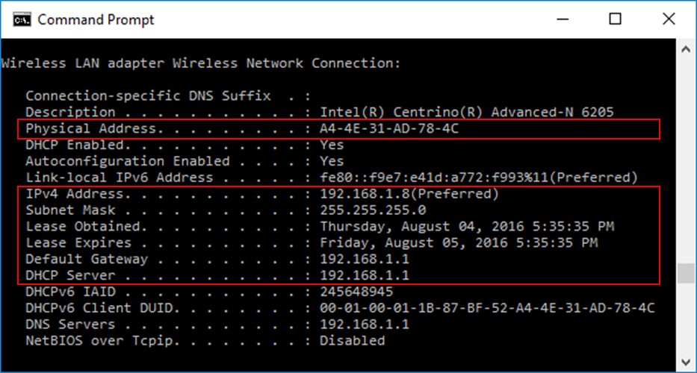
      - Ask a team member for their PC’s IPv4 address and give your PC’s IPv4 address to them. Do not provide them with your MAC address at this time.
Record the IPv4 addresses of the default gateway and the other PCs on the LAN.
____________________________________________________________________________________
    - Start Wireshark and begin capturing data.
      - On your PC, click Start and type Wireshark. Click Wireshark Desktop App when it appears in the search results window.
Note: Alternatively, your installation of Wireshark may also provide a Wireshark Legacy option. This displays Wireshark in the older but widely recognized GUI. The remainder of this lab was completed using the newer Desktop App GUI.
      - After Wireshark starts, select the network interface that you identified with the ipconfig command. Enter arp in the filter box. This selection configures Wireshark to only display packets that are part of the ARP exchanges between the devices on the local network.
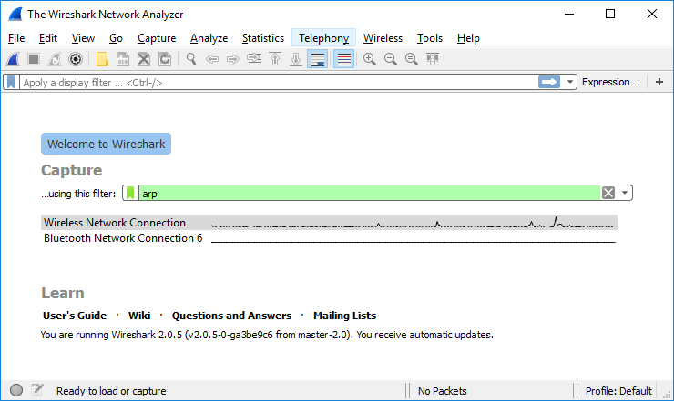
      - After you have selected the correct interface and entered the filter information, click Start () to begin the data capture. Information will start scrolling down the top section in Wireshark. Each line represents a message being sent between a source and destination device on the network.
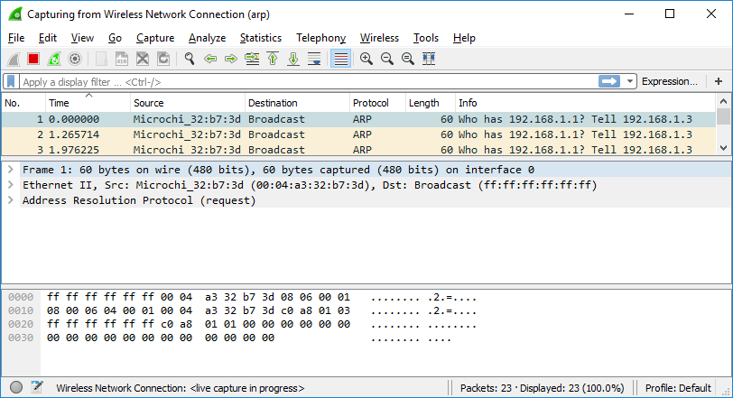
      - Open a command prompt window. Use the ping command to test connectivity to the default gateway address that you identified in Part 2, step 1c.
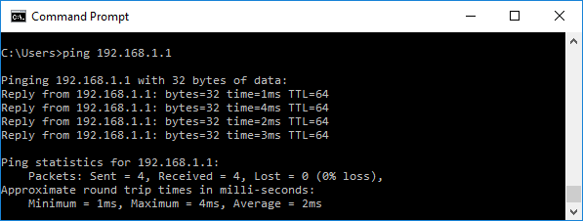
      - Ping the IPv4 addresses of other PCs on the LAN that were provided to you by your team members.
Note: If your team member’s PC does not reply to your pings, this may be because their PC firewall is blocking these requests. Ask your instructor for assistance if necessary to disable the PC firewall.
      - Stop capturing data by clicking Stop Capture () on the toolbar.
    - Examine the captured data.
In Step 3, examine the data that was generated by the ping requests of your team member’s PC. Wireshark data is displayed in three sections:
        - The top section displays the list of PDU frames captured with a summary of the IPv4 packet information listed.
        - The middle section lists PDU information for the frame selected in the top part of the screen and separates a captured PDU frame by its protocol layers.
        - The bottom section displays the raw data of each layer. The raw data is displayed in both hexadecimal and decimal form.
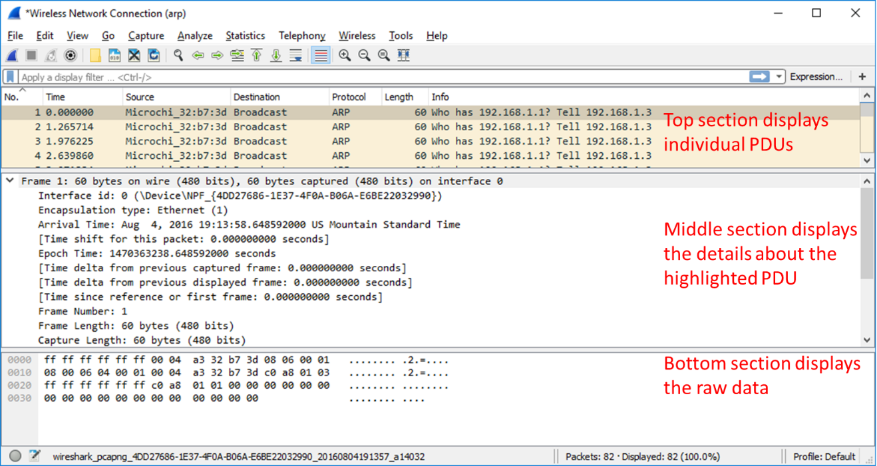
      - Click one of the ARP frames in the top section that has your PC MAC address as the source address in the frame and “broadcast” as the destination of the frame.
      - With this PDU frame still selected in the top section, navigate to the middle section. Click the arrow to the left of the Ethernet II row to view the Destination and Source MAC addresses.
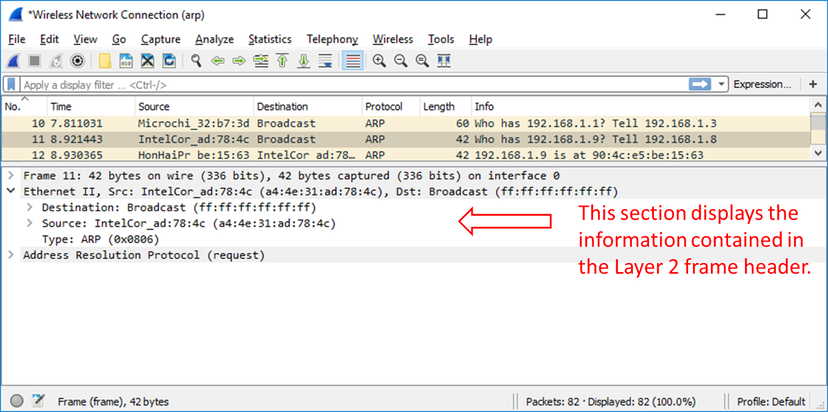
Does the Source MAC address match your PC’s interface?
      - Click the arrow to the left of the Address Resolution Protocol (request) row to view the content of the ARP request.
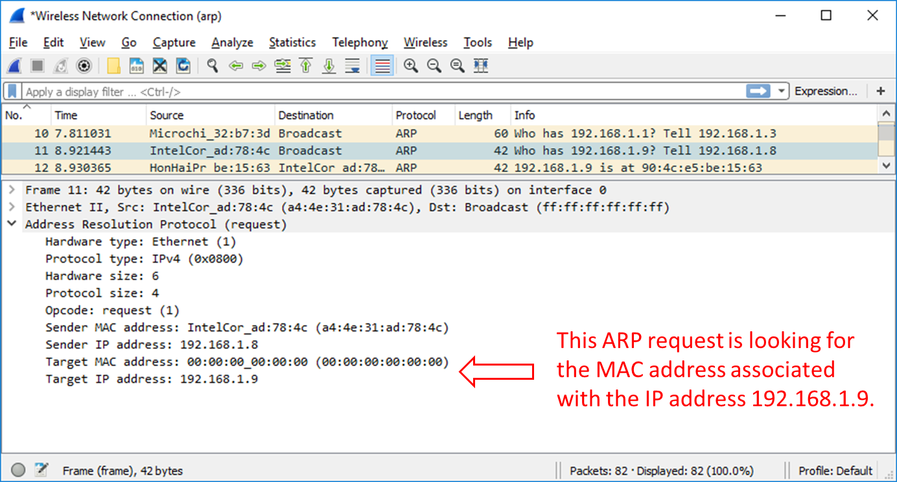
    - Locate the ARP response frame that corresponds to the ARP request that you highlighted.
      - Using the Target IPv4 address in the ARP request, locate the ARP response frame in the upper section of the Wireshark capture screen.
What is the IPv4 address of the Target device in your ARP request?
      - Highlight the response frame in the upper section of the Wireshark output. You may have to scroll the window to find the response frame that matches the Target IPv4 address identified in the previous step. Expand the Ethernet II and Address Resolution Protocol (response) rows in the middle section of the screen.
Is the ARP response frame a broadcast frame?
What is the destination MAC address of the frame?
Is this the MAC address of your PC?
What MAC address is the source of the frame?
      - Verify with your team member that the MAC address matches the MAC address of their PC.
- Examine the ARP cache entries on the PC.
After the ARP reply is received by the PC, the MAC Address to IPv4 address association is stored in cache memory on the PC. These entries will stay in memory for a short period of time (from 15 to 45 seconds), then, if they are not used within that time, they will be removed from cache.
    - View ARP cache entries on a Windows PC.
      - Open a command prompt window on the PC. At the prompt, enter arp –a and press enter.
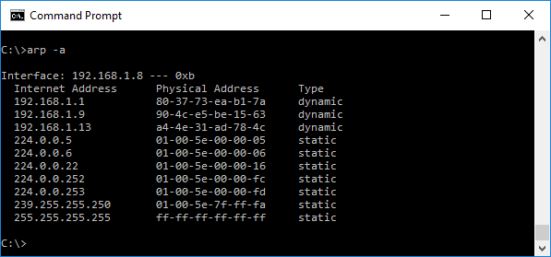
The output of the arp –a command displays the entries that are in the cache on the PC. In the example, the PC has entries for the default gateway (192.168.1.1) and for two PCs that are located on the same LAN (192.168.1.9 and 192.168.1.13).
What is the result of executing the arp –a command on your PC?
____________________________________________________________________________________
____________________________________________________________________________________
      - The arp command on the Windows PC has another functionality. Enter arp /? at the command prompt and press enter. The arp command options enable you to view, add and remove ARP table entries if necessary.
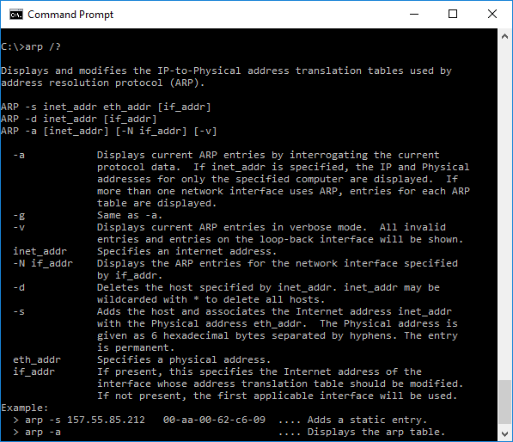
Which option deletes an entry from the ARP cache?
What would be the result of issuing the arp –d * command?

Reflection
  - What is a benefit of keeping ARP cache entries in memory on the source computer?
_______________________________________________________________________________________
_______________________________________________________________________________________
  - If the destination IPv4 address is not located on the same network as the source host, what MAC address will be used as the destination target MAC address in the frame?
_______________________________________________________________________________________
_______________________________________________________________________________________

